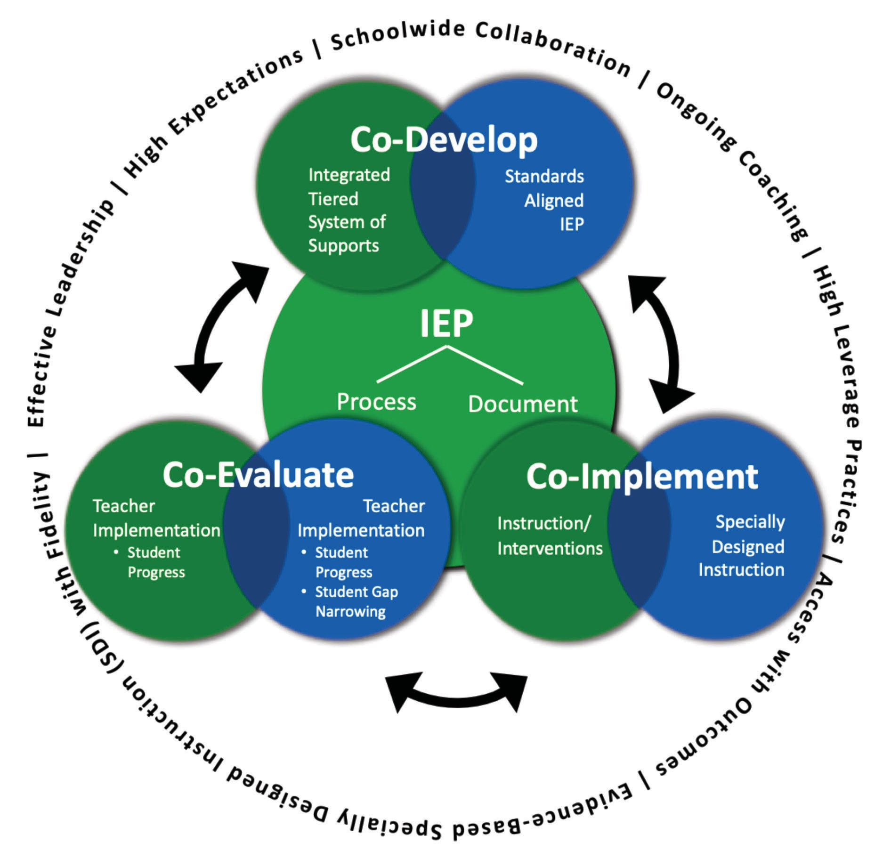
HOWARD COUNTY PUBLIC SCHOOL SYSTEM
OFFICE OF SPECIAL EDUCATION
IEP Process Performance Indicators

DIVISION OF EARLY INTERVENTION AND SPECIAL EDUCATION SERVICES (DEI/SES)
INDIVIDUALIZED FAMILY SERVICE PLAN (IFSP) COMPLIANCE AND BEST PRACTICE STANDARDS
IEP PROCESS PERFORMANCE INDICATORS

When developing, implementing, and evaluating IEPs, the IEP Team considers the student’s present levels of performance (for preschoolers, this includes the functional skills and behaviors in the following areas: positive social-emotional skills and social relationships; the acquisition and use of knowledge and skills to successfully participate in activities and routines; and the use of appropriate behaviors to meet needs that lead to increased independence), the impact of specially designed instruction, the student’s previous rate of academic growth, progress toward grade-level proficiencies, any behaviors impacting the student’s progress, and additional input provided by the student’s family. The IEP Team uses the information found in the IEP to develop, implement and evaluate specially designed instruction to accelerate the student’s progress toward grade level achievement.

The Maryland State Department of Education offers this IEP Process Performance Indicators tool to assist local school systems (LSSs), and public agencies (PAs) in examining the extent to which IEPs are both compliant and reflect best practices for student with disabilities and their families, the two pillars of performance. This tool presents an overview of each component of the IEP process followed by compliance indicators and best practice indicators based on national literature and current practices in Maryland.

The following resources and materials further support the implementation of the IEP process with fidelity:
- The MSDE Technical Assistance Bulletin # 19-01 Improving Outcomes for Students with Disabilities Curriculum, Instruction and Assessment – legal and programmatic guidance for the implementation of SDI within an Integrated, Tiered System of Supports (ITSS)
- A Guide for Implementing Specially Designed Instruction within an Integrated, Tiered System of Supports – implementation guide to support teams in the collaborative development, implementation and evaluation of SDI for students with disabilities
- The MSDE Technical Assistance Bulletin # 17-02 Parental Consent Under Maryland Law – legal guidance and frequently asked questions about parental consent relative to the IEP process
- The MSDE Technical Assistance Bulletin #19-02 Student Behavior Interventions: Physical Restraint and Seclusion Supplement on Students with Disabilities – supplemental guidance on the use of restraint and seclusion for students with disabilities and considerations for IEP process and documentation

This tool is intended to serve as a means for LSSs, and PAs to identify areas of strength and areas for improvement in both indicators of performance: compliance and best practice. Results can be used to guide reflective coaching and conversations to build capacity.

Compliance Indicators Scoring: Best Practice Indicators Scoring:
0 = The IFSP/IEP component is noncompliant 0 = No evidence of best practice
1 = The IFSP/IEP component is compliant 1 = Some/emerging evidence of best practice(s)
2 = Full implementation of best practice(s)

MARYLAND IEP PROCESS PERFORMANCE INDICATORS
Component Overview | Compliance Indicator | Compliance Rating  (0-1) | Best Practice Indicator(s) | Best Practice Rating  (0-1-2)
Present Levels of Academic ad Functional Performance
A description of current academic and functional performance is based on data from multiple sources such as: standardized assessments, state and district testing, curriculum-based measures, classroom observations, teacher and family interviews, progress monitoring on academic standards, behavioral data, and progress on IEP goals.  For preschool students, the PLAAFP is organized around the three early childhood outcome areas. | The IEP for a student with a disability shall include a statement of the student’s present levels of academic achievement and functional performance including current:  - individualized assessments results (must include the title and date of the assessment and grade level results if appropriate to the assessment),  - classroom-based assessments,  - district assessments,  - classroom based observations,  - student’s ’s academic/functional strengths,  - parent information, and  - student and general education teacher input in relevant areas.  CFR § 300.320(a)  COMAR 13A.05.01.09A(1)(a)  MSDE Special Education Birth Through 21 Record Review, Part III  - Part B Requirements |  | Standardized scores are one of many sources of data and alone are insufficient. Progress on academic performance based on State standards and IEP goals are gathered and charted over time to describe trend data reflecting rate of growth and gap in performance related to grade level standards.  For preschool students, include functional skills and behaviors related to positive social skills and relationships, acquisition and use of knowledge and skills to participate in activities and use of appropriate behaviors to meet needs, leading to increased independence. A comparison of the child’s functioning to that of typically- developing peers is reflected in the descriptions for each outcome area and is updated at least annually. Team use the Decision Tree, each and every time, to reach consensus about the appropriate outcome descriptor statement.

MARYLAND IEP PROCESS PERFORMANCE INDICATORS
Component Overview | Compliance Indicator | Compliance Rating  (0-1) | Best Practice Indicator(s) | Best Practice Rating  (0-1-2)
The IEP team considers and describes the student’s strengths, interest areas, significant personal attributes and personal accomplishments. Parental concerns and input are documented as well as the student’s communication needs. The team determines if the student requires Assistive Technology devices and/or services and includes a description of the needed devices and services. | In developing an IEP, the IEP team shall consider and document:  - Strengths of the student;  - Concerns of the parent for enhancing the education of the student;  - Communication needs of the student  - Whether the student requires assistive technology devices and services;  - The academic, developmental and functional needs of the student |  | The team uses student strengths to inform IEP decisions which include determining ways to increase engagement and motivation, and to determine potential strategies for teaching skills.  For preschool age students, a specific mechanism to elicit information from preschool parents, such as the document “A Look at My Child’s Development” is used consistently in the assessment process.
 | COMAR 13A.05.01.08A(3)  MSDE Special Education Birth Through 21 Record Review, Part III  - Part B Requirements |  | For students age 14 and above, the student plays an active role in the meeting. The team prepares the student for participation by helping him or her identify strengths, needs, goals and other areas to discuss.
 |  |  | The student’s communication needs and impact on his or her access to the school environment and progress in the grade level curriculum are documented.
Preschool teams consider how communication skills impact: social skills and relationships, acquiring and using knowledge to participate in activities and use of appropriate behavior to meet needs.

Assistive technology is not listed on the Related Services Page as a stand-alone related service. The consideration and documentation of assistive technology need not be limited to any one section of the IEP. Assistive technology is incorporated in any and all areas appropriate for the student.

MARYLAND IEP PROCESS PERFORMANCE INDICATORS
Component Overview | Compliance Indicator | Compliance Rating  (0-1) | Best Practice Indicator(s) | Best Practice Rating  (0-1-2)
The impact statement describes how the student’s disability affects participation (involvement in general education) and learning (making progress toward grade level standards). The impact statement provides specific information that informs the team’s decisions about specially designed instruction.  For preschool students, the impact statement describes how the disability affects the child’s ability to participate in natural and inclusive learning opportunities within daily routines and activities. | The IEP for a student with a disability shall include how the student’s disability affects the student’s involvement and progress in the general curriculum (i.e., the same curriculum as for nondisabled students); or, for preschool students, as appropriate, how the disability affects participation in appropriate activities.  34 CFR §300.320(a)(1) COMAR 13A.05.01.09A(1)(a)  MSDE Special Education Birth Through 21 Record Review, Part III  - Part B Requirements |  | The IEP team addresses the student as a whole when considering the impact of the disability on participation in school life, including socialization, activity engagement and attention, as well as strategies that support learning.  For preschool students, the IEP team frames all discussions about the child’s participation in natural routines and activities across settings within the context of the three early childhood outcomes.

 | MARYLAND IEP PROCESS PERFORMANCE INDICATORS
 | Component Overview | Compliance Indicator | Compliance Rating  (0-1) | Best Practice Indicator(s) | Best Practice Rating  (0-1-2)
 | IEP Goals and Objectives
 | IEP goals and objectives are ambitious and reasonably calculated to enable the student to progress in general education. IEP goals and objectives clearly address learning needs resulting from the student’s disability to enable them to access and make progress in the curriculum.  Academic goals are aligned to the Maryland College and Career Ready Standards (MCCRS) for the grade in which the student is enrolled. For students with significant cognitive disabilities whose parents have consented to participation in the alternate assessment or learning alternate standards, academic goals are aligned to the Core Content Connectors (CCCs) for the grade in which the student is enrolled. For students who require additional academic goals, they are aligned to priority standards from earlier in the learning progression.  For preschool age students, goals and objectives are aligned to the Maryland Early Learning Standards and is related to at least one of the early childhood outcomes.  Functional IEP goals are aligned to age and grade appropriate non-academic skills impacted by the student’s disability.  For students age 14-21, academic and functional IEP goals and objectives support identified postsecondary goals and transition services.  Objectives describe meaningful intermediate outcomes between the student’s current performance level and measurable annual goal. | The IEP for a student with a disability must include measurable academic and functional goals.  Academic and functional goals must be designed to meet the student’s needs that result from the student’s disability to enable the student to be involved in and make progress in the general education curriculum and meet each of the student’s other educational needs that result from the student’s disability.  34 CFR §300.320(a)(2)(i)  34 CFR § 300.320(b)  COMAR 13A.05.01.09A(1)(b) COMAR 13A.05.01.09A(3)(a)(ii)  The IEP for a student determined eligible to be instructed using alternate academic achievement stndards must be aligned with the State’s grade level content standards, although they may be restricted in scope or complexity or take the form of introductory or pre-requisite skills.  34 CFR §200.1(d) and §300.160  MSDE Special Education Birth Through 21 Record Review, Part III  - Part B Requirements |  | Goals address priority skills to enable to the student to achieve or make progress toward grade level standards and/or age appropriate functional skills.  These skills are prioritized within each area of need by reviewing grade and age expectations for the current, future and past grade levels.  For each identified area of need, at least one academic goal is aligned to one or more priority standard in the student’s enrolled grade. Remaining academic goals target those skills from earlier in the learning progression that the student has not yet mastered, but is essential for the student to progress toward achieving grade level standards.  Functional IEP goals are developed in conjunction with all service providers including, but not limited to experts in behavior such as a school psychologist, behavior specialist, speech pathologist, etc.  Goals and objectives are individualized based on the student’s PLAAFP and include the following five components:  - Conditions  - Behavior  - Criteria (Mastery and Retention)  - Method of Measurement  - Time Frame
MARYLAND IEP PROCESS PERFORMANCE INDICATORS
Component Overview |  | Compliance Indicator | Compliance Rating  (0-1) | Best Practice Indicator(s) | Best Practice Rating  (0-1-2)
Objectives are clearly related to the goal and reflect sequential targets of increasing proficiency, accuracy and complexity – or reduced supports across the time period covered by the IEP and/or list the component skills, which when combined, lead to the achievement of the goal.

Objectives have the same essential best practice components as goals as described above (conditions, behavior, criteria, method of measurement, time frame).

Although there does not need to be a separate annual goal developed for each postsecondary goal in the student’s transition plan, the IEP Team considers how the annual goal(s) developed will support postsecondary goals and transition services.

When developing preschool goals, teams need to focus on the functionality of learning and development within the context of natural routines and activities and resist the tendency to develop goals that simply reflect the development of isolated skills driven by evaluation results.

Functional, participation-based goals include ALL of the following:
- The goal is written in plain language and is jargon-free;
- The goal emphasizes the positive;
- The goal describes the child’s involvement in age-appropriate activities to address academic and functional areas;
- The goal is measurable and observable;
- The goal describes how the child will demonstrate what they know or can do; and
- The goal describes the situations in which the child will demonstrate the goal, and does not name a placement or educational environment.

The following IEP goal criteria should also be evaluated:
- The goal includes what the child is doing now and includes the family’s input and concerns.
- The goal is achievable in one year and specific timelines are noted.
- The goal details special factors related to communication, assistive technology, and support specific to the child’s disability and/or English language learning.
The IEP describes how the parents will be informed of the student’s progress on goals and objectives throughout the year.  The IEP includes at least quarterly reports on the student’s progress, including an indication of whether progress is sufficient for the student to meet the goal within one year.  The IEP team reviews the IEP periodically, no less than annually, to determine the impact of specially designed instruction on the student’s performance.  If a student is not making progress at the level the IEP team expected, despite receiving all services and supports identified in the IEP, the IEP team convenes to review and revise the IEP, while maintaining ambitious academic goals. |  | An IEP shall include how a parent is to be regularly informed of:  - The student’s progress toward the annual goals will be measured; and  - The extent to which the progress is sufficient to enable the student to achieve the goals within a year  34 CFR § 300.320(a)(3)(ii) COMAR13A.05.01.09B(1)  MSDE Special Education Birth Through 21 Record Review, Part III  - Part B Requirements |  | IEP Teams report, at least quarterly or in the same frequency as students without disabilities: the gains made during the last IEP period by goal area, factors influencing progress, student’s response to the supports and specially designed instruction implemented, and recommendations for change in order to increase the student’s progress or rate of learning.  These progress reports are based on objective data collected from standard and curriculum assessments, rubrics, structured observations and other relevant data sources. The IEP Team carefully considers how progress monitoring informs specially designed instruction by setting targets that are reasonably calculated for the student and targeted skill(s).  At a minimum, the instructional team reviews student progress quarterly. Progress on goals and objectives and general education measures are reviewed more frequently based on the student’s performance and rate of progress.  If the student is not making adequate progress, the IEP team reviews the student’s entire program, which includes IEP implementation, and makes adjustments as needed to accelerate student progress.  For preschool students, Information from the ELA or other formative assessment is used to inform specially designed instruction as well as annual and exit COS ratings.

