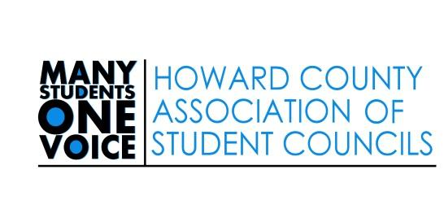

Student Member of the Board of Education Applicant Meeting
Tuesday February 9, 2021

6:00 Welcome and Introductions
James LeMon, Executive Director Community, Parent, and School Outreach
Cindy Drummond, Advisor Howard County Association of Student Councils (HCASC)
Zach Koung, Student Member of the Board of Education
Chris Lidard, HCASC President
Hannah Fang, Student Voice Convention Director

6:10 Description of a Successful Member of the Board of Education
6:20 Student Voice Convention 2/17
  - Students plan, create, lead, and manage the event
  - Middle and High school delegates
  - Delegate Training
  - Voting Guide
  - Agenda for Convention Day
6:30 Next Steps
  - HCASC General Assembly Meeting Wednesday 2/10 7:00-8:30pm
  - Student Voice Convention 2/17
  - Meeting for final 2 candidates and parents/ guardians 2/22 at 6:00pm
  - Official campaign begins after the 2/22 meeting
  - HCASC Meeting and Candidate forum 3/10 7:00-8:30pm
  - HCASC General Assembly Meeting 4/7 7:00-8:30pm
  - General Election 5/3-5/5
6:45 Closing
  - Review the “To Do” List
  - Question and Answer
7:00 Adjourn

Student Member of the Board of Education Applicant “To Do” List

- Attend HCASC meeting 2/10 7:00-8:30 RSVP https://bit.ly/35K4Aud

- As you prepare for the Convention think about, “Of all the students applying for the Student Member Position, what sets you apart?”

- Prepare your 1 minute opening statement for the Convention

- Prepare to address the following topics in Q and A
  - 45 second responses
  - Ways to represent the student voice
  - Challenge you overcame
  - Traits you admire in others
  - Managing disagreements
  - Working with adults/ demonstrating professional behavior
  - Review your application responses
  - Topics you feel passionate about

- Prepare for Round Robin
  - 7 sessions
  - 8 minutes each
  - Delegates will self select breakout rooms

- Prepare your 1 minute closing statement for the convention

- Attend the Convention 2/17
  - Log In at 8:30am
  - Walk through Zoom and familiarize yourself with the platform
  - Prepare speaking points

- Promote and support the Student Member of the Board of Education Process
  - Share your experience
  - Serve as an informed applicant, candidate, student at large
  - Participate in HCASC- appointed officer and policy review committee
  - Attend the Student Member Candidate Forum 3/10 7:00-8:30pm
  - Attend the HCASC meeting 4/14 7:00-8:30pm

Successful Applicants for the Student Member of the Board of Education Position will follow all HCPSS policies and procedures with specific attention to
- 1000 – Civility
- 1010 – Discrimination
- 1020 – Sexual Discrimination
- 1040 – Safe and Supportive Schools
- 1050 – Tobacco-Free Environment
- 1060 – Bullying, Cyberbullying, Harassment, or Intimidation; BHI Reporting Form
- 9000 – Student Residency, Eligibility, Enrollment and Assignment
- 9010 – Attendance
- 9020 – Students’ Rights and Responsibilities
- 9030 – School-Sponsored Publications and Productions
- 9070 – Academic Eligibility for High School Extracurricular Activities
- 9200 – Student Discipline – See also: Student Code of Conduct
- 9210 – Student Dress Code
- 9230 – Alcohol, Other Drugs, Prescription Medication and Over-the-Counter Products
- 9400 – Student Behavior Intervention

